- Quadratic equations

1. Given that 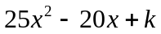is a perfect square. Find the value of k. (2 mks)
2. Simplify 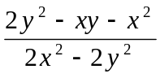 (3mks)
3. Solve the following quadratic equation giving your answer to 3 d.p. (3mks)
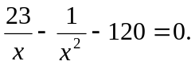
4. Simplify (3 mks)
16x² - 4 ÷ 2x – 2
4x² + 2x - 2 x + 1
5. Simplify as simple as possible 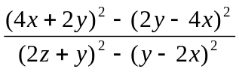 (3 mks)
6. In a triangle ABC, angle B is 90º. Find the value of x and hence the area of the triangle
C
(7x + 2)cm
(3x + 5)cm
√611
B
A

7. Solve the following inequalities and represent the solution on a number line hence state
the integral values 7x – 4 ≤ 9x + 2 < 3x + 14

